Setting Up Application Environment

|  |  |
| --- | --- |
| Date | 2022-10-31 |
| Team ID | PNT2022TMID31805 |
| Project Name | Personal Expense Tracker Application |

**Create Flask App**

**Step 1:**

Install the latest version of Python in your desktop link <https://www.python.org/downloads/>

**Step 2:**

After that, Create new file in your desktop and open command prompt here and type this below command to install the flask. Then the flask will install in few seconds ass shown below

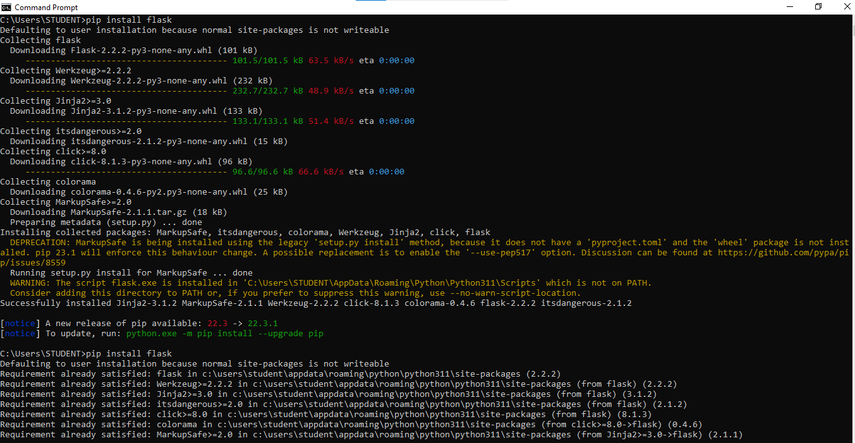

**Step 3:**

Then you can check whether the flask is installed or not in a system, by tying these Command in

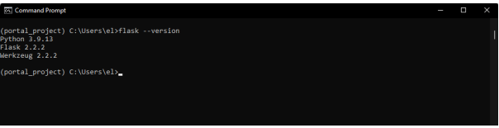

**Step 4:**

Open Visual Studio Code and enter the code given below,

from flask import Flask

app = Flask(__name__)

@app.route("/")

def hello_world():

return "<p>Hello, World!</p> "

**Step 5:**

Save the code and give the file name as app.py.

**Step 6:**

Go to the file location and open command prompt and type this command in command prompt:

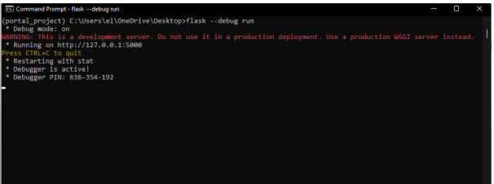

**Step 7:**

Click the Link (or) Copy the address ( https://127.0.0.1:5000 ) and put it, in the browser and click enter. Then the Result will be same as the below screenshot

